**Group:** Team ONE  
**Program Name:** Stellar

USER GUIDE - How to Operate the Program

**Summary:**

1) You need to manually set the database location on the DatabaseConnection.java file

2) You may need to add dependencies to the jar files depending on IDE used. Instructions on the bottom.

a) Add dependencies for the rs2xml.jar (Eclipse)  
b) Add dependencies for both if using Intellij.

Step 1:

The database file has to be set manually in the DatabaseConnection.java file.

1) On line 23: Connection conn = DriverManager.getConnection("jdbc:sqlite:D:\\IdeaProjects\\Stellar\\src\\stellar\\DataBase.db");

2) Change the database location to where it is in the drive.

3) For example, if the DataBase.db is located in Drive H:\Stellar folder then it would say,

Connection conn = DriverManager.getConnection(jdbc:sqlite:H:\\Stellar\\DataBase.db");

Step 2:

Once the database has been setup then it can now be run properly.

1) Run Stellar.java

2) Gui opens, use the sample id and password to login to the system.

ex. username: gturner28

pass: pass

Features (Build 2):

This build focused on admin page (“Update Student Information”).

1. You can change the user’s current password by selecting the password on the toolbar and following the prompts. This change will be permanent as it writes to the database.
2. Select “Update Student Information” from the left and you can add classes, students, teachers, instructors for classes. Update classes can be ignored as will be removed in the next build.
3. As you add items to the database you will see the actual changes to the database in the left.

**Possible Required Steps:

**a) Add dependency for Eclipse.**

“You can add a jar in Eclipse by right-clicking on the Project → Build Path → Configure Build Path. Under Libraries tab, click Add Jars or Add External JARs and give the Jar.

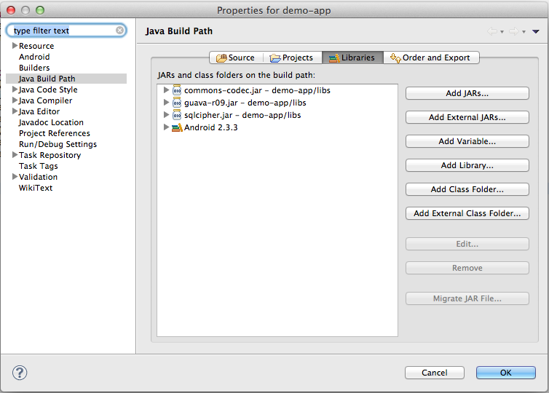”- source: stackoverflow.com

**b) Add dependencies for intellij. Both files.**

Steps:

1) Go to project structure -> Modules -> Dependencies

2) Click the '+' button on the right then browse to the project location and onto the .jar file. Do it for each jar file.

* To access the Administrator page, login to the Stellar dashboard and click on “Update Student Information”.
* The Administrator page is only located there for testing.

**Login Info**

Student ID: aturner22

Password: cats

Student ID: gturner28

Password: pass

Student ID: ehmar

Password: pass

Student ID: houldhamou1

Password: password

Student ID: gfausti1

Password: pass